Invoke lambda via API Gateway

**Scenario**: When you invoke your HTTP API, API Gateway routes the request to your Lambda function. Lambda runs the Lambda function and returns a response to API Gateway. API Gateway then returns a response to you.

* [Step 1: Create a Lambda function](https://docs.aws.amazon.com/apigateway/latest/developerguide/getting-started.html#getting-started-create-function)
* [Step 2: Create an HTTP API](https://docs.aws.amazon.com/apigateway/latest/developerguide/getting-started.html#getting-started-create-api) and attach to lambda

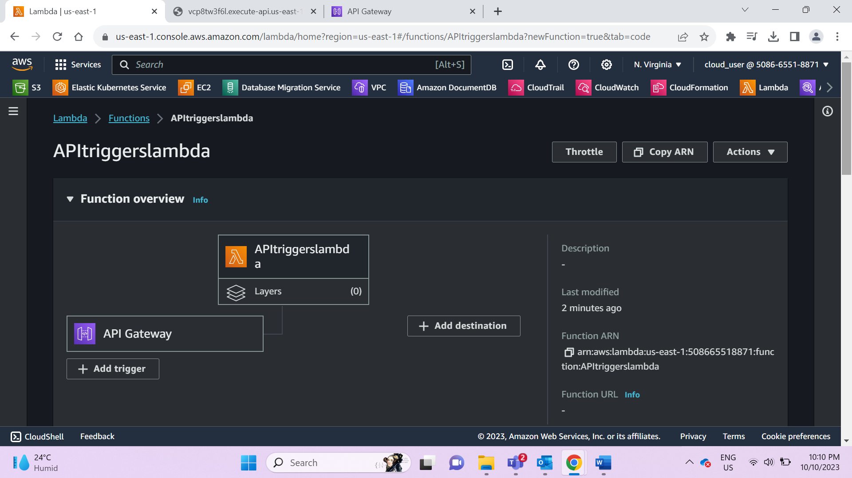

* [Step 3: Click](https://docs.aws.amazon.com/apigateway/latest/developerguide/getting-started.html" \l "getting-started-invoke-api) on API Endpoint URL under triggers in lambda

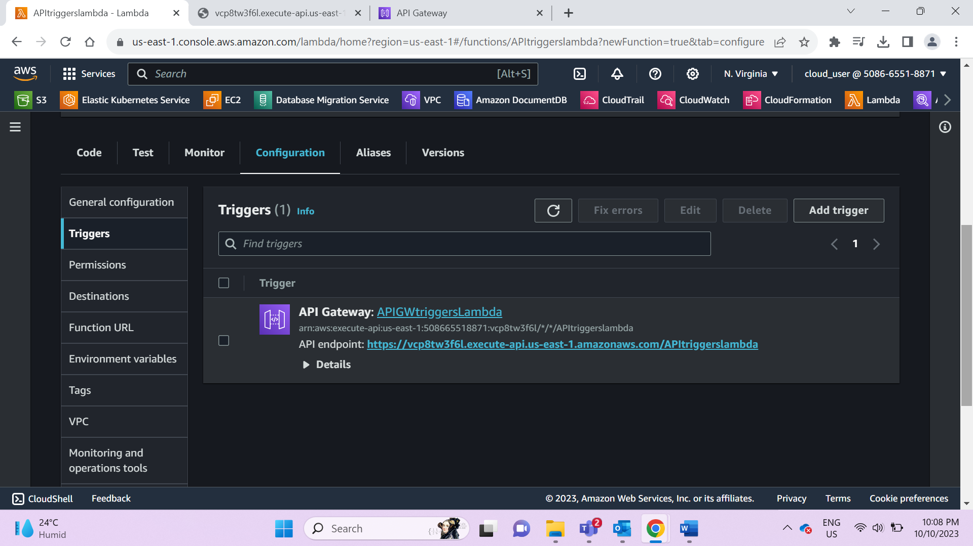

Results:

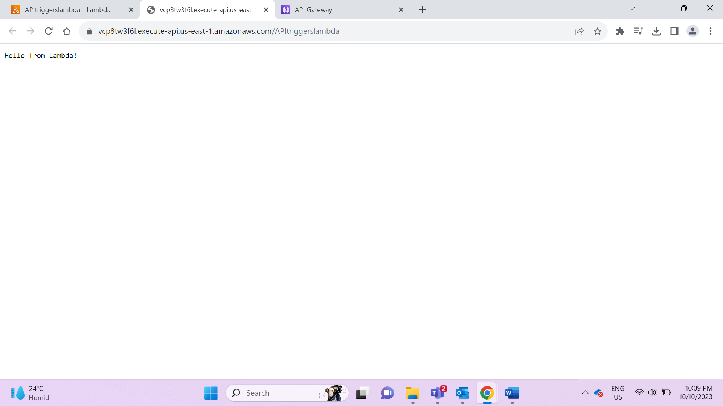

Code:

import json

def lambda_handler(event, context):

# TODO implement

return {

'statusCode': 200,

'body': ('Hello from Lambda!')

}